Khan Academy: Interpreting Linear Graphs Word Problems Example 1.
https://www.youtube.com/watch?v=xR9r38mZjK4

The graph below shows how the volume of a flexible, gas-filled balloon changes when the temperature is increased or decreases. The “dashed” part of the line signifies that no data was collected in that range

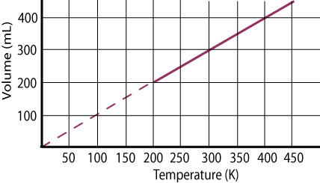
- As the temperature is increased, the volume of the gas:
- Increases
- Decreases
- Remains constant
- There is not enough information to answer the question
- The volume of the gas at a temperature of 300 K is:
- 0 mL
- 100 mL
- 200 mL
- 300 mL
- If the temperature increases from 200 K to 400 K, the volume changes by:
- 400 mL
- 200 mL
- 0 mL
- There is not enough information to answer the question.
- Which of the following conclusions can be drawn from the graph?
- A 100 Kelvin temperature change will always change the volume by 100 mL
- A 100 Kelvin temperature increase has a bigger effect on the volume at 200 K than at 350 K
- A 100 Kelvin temperature increase has a bigger effect on the volume at 350 K than at 200 K
- Increasing or decreasing the temperature has no effect on volume.

