Khan Academy: Interpreting Linear Graphs Word Problems Example 2.
https://www.youtube.com/watch?v=qo5jU_V6JVo
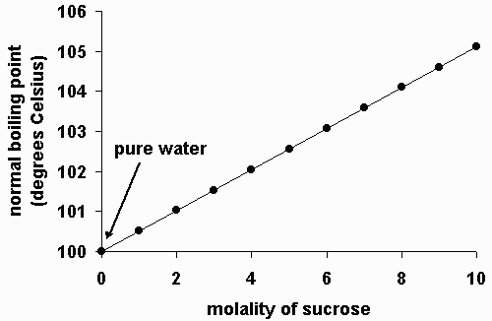
The graph above shows how the boiling point of a water/sugar mixture depends upon the concentration of sugar (sucrose) that is dissolved in the water. The concentration has units of “molality”. If there is no sugar present in the mixture, then only water is present, and the molality is 0.

- Which of the following inferences can be drawn from the graph?
- As the molality decreases (if we add less sugar), then the boiling point will increase.
- As the molality increases (if we add more sugar), then the boiling point will increase.
- The boiling point does not depend on the molality.
- None of the above inferences is correct.
- The slope of the line in the graph is:
- Positive
- Negative
- Zero
- Undefined
- Which of the following physical interpretations could we give to the slope?
- It gives the amount of change in the boiling point for a unit change(i.e.,change of 1) in the concentration (molality)
- It describes how quickly the sugar is dissolving.
- It shows how quickly the boiling point is changing.
- None of these interpretations is correct.
- When the molality is “8”, the boiling point of the solution is closest to:
- 104 ⁰C
- 101 ⁰C
- 102 ⁰C
- 105 ⁰C

- From the graph, an increase of 2 units in the molality will increase the boiling point by:
- 1 ⁰C
- 2 ⁰C
- 6 ⁰C
- Increasing the molality has no effect on the boiling point.

